Self-Efficacy for Exercise Scale
Now I am going to give situations that might affect your participation in exercise.
For each one, use this scale where 0 is Not Confident and 10 is Very Confident, to tell
me how confident you are right now that you could exercise 3 times a week for 20 minutes
each time, in each of these situations:

l. If the weather was bothering you 0 1 2 3 4 5 6 7 8 9 10

2. If you were bored by the program or activity 0 1 2 3 4 5 6 7 8 9 10

3. If you felt pain when exercising 0 1 2 3 4 5 6 7 8 9 10

4. If you had to exercise alone 0 1 2 3 4 5 6 7 8 9 10

5. If you did not enjoy it 0 1 2 3 4 5 6 7 8 9 10

6. If you were too busy with other activities 0 1 2 3 4 5 6 7 8 9 1 0

7. If you felt tired 0 1 2 3 4 5 6 7 8 9 10

8. If you felt stressed 0 1 2 3 4 5 6 7 8 9 10

9. If you felt depressed 0 1 2 3 4 5 6 7 8 9 10

Outcome Expectations for Exercise Scale
Now I'm going to read you nine different statements about the benefits of exercising,
like walking, jogging, swimming, biking, stretching, or lifting weights. On this scale
from 1 to 5, where 1 means you Strongly Disagree, and 5 means you Strongly Agree,
please state how much you agree or disagree with each statement.

1. Exercise makes me feel better physically
Strongly Disagree 1 Disagree 2 Neither agree nor disagree 3 Agree 4 Strongly Agree 5

2. Exercise makes my mood better in general
Strongly Disagree 1 Disagree 2 Neither agree nor disagree 3 Agree 4 Strongly Agree 5

3.. Exercise helps me feel less tired
Strongly Disagree 1 Disagree 2 Neither agree nor disagree 3 Agree 4 Strongly Agree 5

4. Exercise makes my muscles stronger
Strongly Disagree 1 Disagree 2 Neither agree nor disagree 3 Agree 4 Strongly Agree 5

5, Exercise is an activity I enjoy doing
Strongly Disagree 1 Disagree 2 Neither agree nor disagree 3 Agree 4 Strongly Agree 5

6. Exercise gives me a sense of personal accomplishment
Strongly Disagree 1 Disagree 2 Neither agree nor disagree 3 Agree 4 Strongly Agree 5

7. Exercise makes me more alert mentally
Strongly Disagree 1 Disagree 2 Neither agree nor disagree 3 Agree 4 Strongly Agree 5

8. Exercise improves my endurance in performing my daily activities (personal care,
cooking, shopping, light cleaning, taking out the garbage)
Strongly Disagree 1 Disagree 2 Neither agree nor disagree 3 Agree 4 Strongly Agree 5

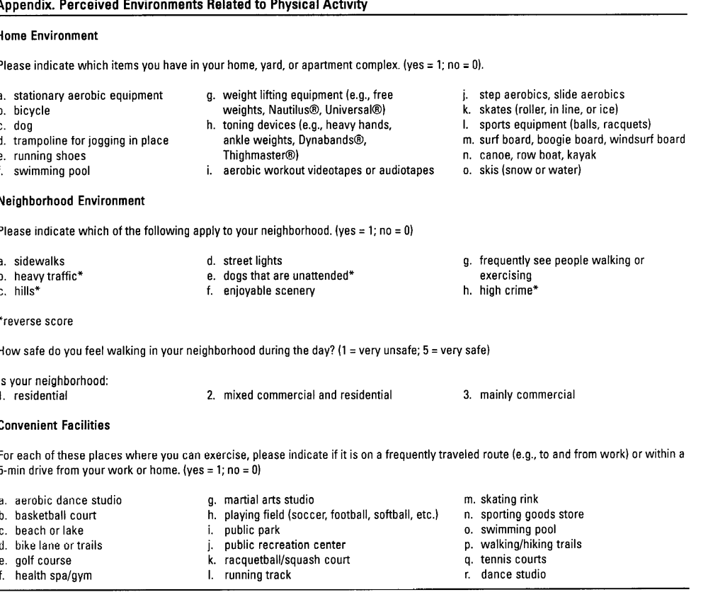

Section 7: Physical Activity
Questionnaire
Based on the International Physical Activity Questionnaire for Young and Middle-aged Adults (IPAQ-YMAA-L1-D2) I will now ask you some questions about your physical activity during the week. I will ask you to answer each question even if you don’t consider yourself to be an active person. To this end, consider the physical activity involved: in your work; in getting from one place to another; in recreational and sports activities; and in household chores; for example, gardening, carpentry work, physical labor or other activities necessary for household maintenance.

7.1 How many days per week do you walk briskly for at least 10 minutes to get from one place to another, engage in sports or recreation?
1. Days per week
2. Don’t care to respond
3. Don’t know
7.2 On days that you walk, how long do walk?
1a. Hours
1b. Minutes
2. Don’t care to respond
3. Don’t know
7.3 Typically (ordinarily, usually), how many days per week do you perform moderate physical activities for a period of at least 10 minutes, such as: riding a
bicycle at a normal speed; swim at a normal speed; rake or pick up leaves; or sweep floors (please do not include walking in your response)?
1. Days per week
2. Don’t care to respond
3. Don’t know
7.4 On days when you do these types of physical activity, how much time do you spend doing them?
1. Days per week
2. Minutes
7.5 Typically (ordinarily, usually), how many days per week do you perform vigorous physical activities for a period of at least 10 minutes, such as digging, jogging, high-speed cycling, fast swimming, playing soccer, or shoveling snow?
1. Days per week
2. Don’t care to respond
3. Don’t know

7.6 On days you do these types of physical activity, how long do you spend doing them?
1a. Hours
1b. Minutes
2. Don’t care to respond
3. Don’t know

7.7 Do you think that physical exercise is good for your health?
1. Yes
2. No
3. Don’t know/not sure
7.8 Has a doctor, nurse or other health professional ever advised you to exercise?
1. Yes
2. No
3. Don’t know/not sure

7.9 What is the main reason your doctor has recommended that you do physical exercise?
1. To keep healthy
2. To maintain or control body weight
3. As a supplemental treatment for a specific physical ailment I have
4. Other reason
5. Don’t know why/not sure No

7.10 If you decided to start a program of physical exercise, or you already do so now, do you know of a place where you can go to get advice/help on how to go about it?
1.. Yes  
2. No
3. Don’t recall/not sure
7.11 If you decided to start a program of physical exercise, or you already do so now, do you feel that there are adequate facilities (space, specific areas, sufficient security) in place for this purpose?
1.. Yes  
2. No
3. Don’t recall/not sure
Self-Efficacy for Exercise Scale and Outcome Expectations for Exercise Scale:

Resnick, B., Luisi, D., Vogel, A., Junaleepa, P. (2004). Reliability and Validity of the self-efficacy for exercise and outcome expectations for exercise scales with minority older adults. Journal of Nursing Measurement12 (3), 235-247.

Perceived Environments related to Physical Activity:

Sallis, J. F., Johnson, M. F., Calfas, K. J., Caparosa, S., Nichols, J. F. (1997). Assessing perceived physical environmental variables that may influence physical activity. Research Quarterly for Exercise and Sport 68 (4), 345-351.

International Physical Activity Questionnaire for Young and Middle-aged Adults (IPAQ-YMAA-L1-D2):

World Health Organization (2010). International physical activity questionnaire for young and middle-aged adults. Retrieved on February 21, 2010 from http://www.paho.org/english/hcp/hcn/physical_activity-questions.

